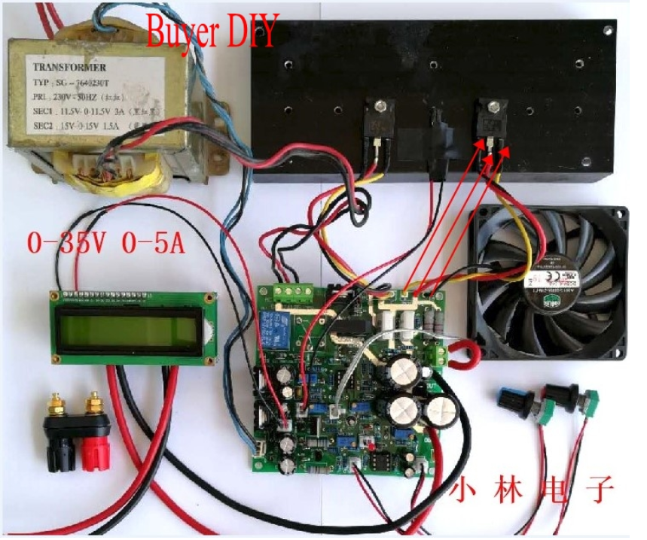Note the 11.5-0-11.5 Volt 3-Amp transformer.

One relay has been omitted and replaced by a jumper.

The non-standard volt/ammeter is powered by the utility 5-volt system.

The off-board V & A pots are only two wire.

The NTC jack has not been fitted.

**This is not the board that I received!**